Preparation of Papers for the Iraqi Journal of Computers, Communications and Control & Systems Engineering
First A. Author¹, Second B. Author², Third C. Author³
¹First A. Author, ²Second B. Authors, ³Third C. Author’s affiliation and address including e-mails

Abstract— These instructions give you guidelines for preparing papers for the Iraqi Journal of Computers, Communication and Control & System Engineering (IJCCCE). Use this document as a template if you are using Microsoft Word (preferable). Otherwise, use this document as an instruction set. Each paper must have an abstract of about 200 words. Define all symbols used in the abstract. Do not cite references in the abstract. Abstract has a function to encourage other authors/readers to read the manuscript. The aim, main contribution, and the important results in terms of quantitative results should be highlighted in the abstract.
Index Terms— About four key words or phrases in alphabetical order, separated by commas.
- INTRODUCTION
In the introduction section, the manuscript topic should be briefly established in a comprehensive context, highlighting its significance. The current state of the topic investigated should be reviewed sensibly, with key more recent publication cited related with the research. In the last paragraph, the aim/purpose and importance of the investigated topic should be clearly defined compared with previous literature.
The official language of the Iraqi Journal of Computers, Communications and Control & Systems Engineering (IJCCCE) is English. All articles will be electronically submitted, reviewed and published in this language only. The articles will be available through the Internet, free of charge, for viewing and printing. It is assumed that by submitting an article the authors consent with free distribution of their work, and transfer all rights under existing copyright laws to the Iraqi Journal of Computers, Communications and Control & Systems Engineering (see Section V). A substantial advantage of the electronic publishing format is the speed in preparing and releasing the work, which protects its originality. An effort will be made to publish the accepted articles in the nearest possible number of the Journal, which currently has a periodicity of six months.
- GUIDELINES FOR PREPARING YOUR PAPER
Manuscripts should be especially prepared for publication in the Iraqi Journal of Computers, Communications and Control & Systems Engineering (IJCCCE) accordingly with the guidelines presented here and are subject to review by the Editors and their staff of reviewers.
Acceptable formats for the text are Microsoft Word (preferable) or LATEX. LaTex submission must be in “Portable LaTex” (*.tex) or “wrap” (*.tex) formats.
The text should be typed one and a half spaced in one column and of size A4 (21 x 29.7 cm), including figures, tables and references. All margins should be set to 2.54 cm (1 inch). The use of a proportionally spaced font is recommended preferably 11-point Times New Roman for text.
All sections, equations, figures, tables, footnotes and references must be numbered throughout the text. Section Titles should be numbered with roman numbers: I, II, etc. Subsection Titles should be numbered with capital letters: A, B, etc. The type sizes used in this template are shown in Table 1.
The final version of the accepted paper will not be formatted by the Journal
The final version of the accepted paper will not be formatted by the Journal staff and will be published as it is. So, follow these types as closely as you can.
- TEMPLATE
This document is a template for Microsoft Word. Alternatively, the software Writer should be used. It is included in the Free Office Suite (see http://www.openoffice.org). Please check for eventual incompatibility. The style will adjust your fonts and line spacing. Please do not change the font sizes or line spacing.
Table 1. Type sizes and appearance
Times New Roman | Type Size (pts) | Appearance
Title | 22 | Capitalize Each Word
Authors’ Names | 11
Authors’ Affiliation | 10
Abstract | 11 | Italic
Index terms | 10 | Italic
section TItles | 11 | UPPERCASE
Text (1.15 spaced) | 11
Subheadings | 11 | Italic
Equations | 11
Tables, Figure captions | 9
Footnotes, References | 9
  - Equation
Use either the Microsoft Equation Editor or the MathType add-on for all math objects in your paper. When numbering equations, enclose numbers in parentheses and align with the right margin of the column as in (1). It is not necessary to include one line of space between the text and equations.
$∇×E=-∂B$ (1)
Be sure that the symbols in your equation have been defined before the equation appears or immediately following.
  - Figures and Tables
Figures and tables should be inserted in the text body, centered, and following its reference. Figure captions should be below the figures and centered as shown in Fig. 1; table captions should be placed above the table, as shown in Table I. When referring to a figure use Fig. For numbering of tables use roman numerals as demonstrated in Table I.
Except for very detailed figures, all figures must occupy no more than half of a page. Colored figures are acceptable. All figures, including drawing and photos, must be included in the text body. Do not include line spaces between figure and its caption. It is not necessary to include one line of space between text and figures and tables.
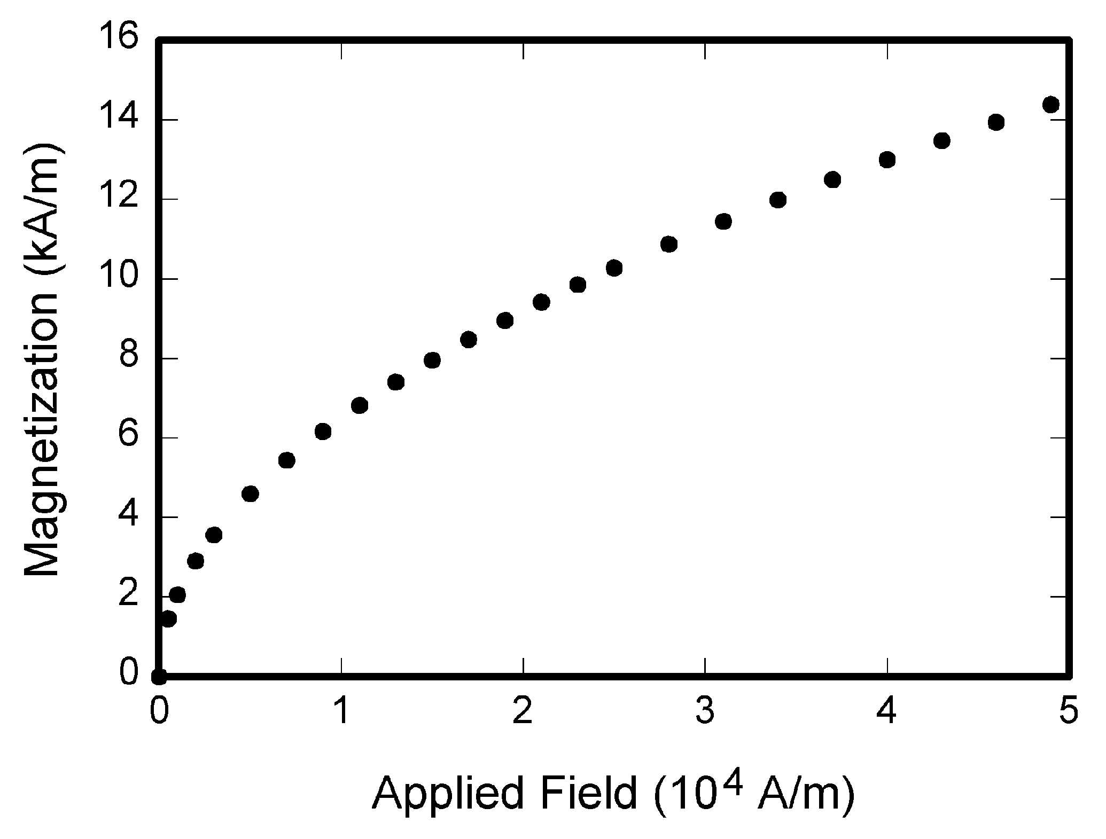
Fig. 1. Magnetization as a function of applied field. Note that "Fig." is abbreviated [1].
  - Abbreviations and Acronyms
Define abbreviations and acronyms the first time they are used in the text, even after they have already been defined in the abstract.
  - References
Number citations consecutively in square brackets [1]. The sentence punctuation follows the brackets [2]. Multiple references [2], [3] are each numbered with separate brackets [1]-[3]. When citing a section in a book, please give the relevant page numbers [2]. In sentences, refer simply to the reference number, as in [3]. Do not use "Ref. [3]" or "reference [3]" except at the beginning of a sentence: "Reference [3] shows ..."
- PAPER SUBMISSION
Note that there is no need to print the articles. An online system for submission of manuscripts at www.jmoe.org guides you through the process of entering your article and uploading your files. The system converts your editable (Word and LaTeX) article files to a PDF file used in the peer-review process. All correspondence, including notification of the Editor's decision and requests for revision, is sent by e-mail. Please, submit your final file as Microsoft Word “.doc”. Please direct all questions to e-mail ijccce@uotechnology.edu.iq.
- COPYRIGHT
Download the copyright form, sign it and upload the signed form to the system.

CONCLUSIONS
In conclusions section, the main conclusions and findings should clearly explain, highlighting its significance. The research limitations and future work directions may also be stated. Please do not write another abstract. It should not include anything not validated in the main text.

APPENDIX
Appendices, if needed, appear before the acknowledgment.

CONFLICT OF INTEREST
For each source of funds, both the funder of the research and the grant number must be provided where all benefits in any commercial party form associated directly or indirectly to the topic of this research must be given here. It should be provided in a separate section before the references list.
ACKNOWLEDGMENT
REFERENCES
- G. Eason, B. Noble, and I.N. Sneddon, “On certain integrals of Lipschitz-Hankel type involving products of Bessel functions,” Phil. Trans. Roy. Soc. London, vol. A247, pp. 529-551, April 1955. (references)
- J. Clerk Maxwell, A Treatise on Electricity and Magnetism, 3rd ed., vol. 2. Oxford: Clarendon, 1892, pp.68-73.
- I.S. Jacobs and C.P. Bean, “Fine particles, thin films and exchange anisotropy,” in Magnetism, vol. III, G.T. Rado and H. Suhl, Eds. New York: Academic, 1963, pp. 271-350.
- K. Elissa, “Title of paper if known,” unpublished.
- R. Nicole, “Title of paper with only first word capitalized,” J. Name Stand. Abbrev., in press.
- Y. Yorozu, M. Hirano, K. Oka, and Y. Tagawa, “Electron spectroscopy studies on magneto-optical media and plastic substrate interface,” IEEE Transl. J. Magn. Japan, vol. 2, pp. 740-741, August 1987 [Digests 9th Annual Conf. Magnetics Japan, p. 301, 1982].
- M. Young, The Technical Writer’s Handbook. Mill Valley, CA: University Science, 1989.

