**NOMENCLATURE**

Ac=the area of collector (m2).

Cp=the specific heat of air at constant pressure (1.008 kJ/kg.K).

m**.** = the mass flow rate (kg/s).

SAH= the solar air heater.

Tin = the inlet temperature of the cooling fluid (oC).

Tout = the outlet temperature of cooling fluid (oC).

V**.** =the volume of the air leaving the collector by the duct with diameter d (m3/s).

v= the air speed in (m/s).

ρ = the density of air in (kg/m3).

P= the air pressure (101325 Pa).

R= the specific gas constant for dry air (287.05 J/kg.K).

= the solar air heater (SAH) efficiency.

= the useful heat gain.

**1- INTRODUCTION**

Solar air heater (SAH) is extensively used in industrial, residential and agricultural fields. Experimental studies reported various methods used for drying of agricultural materials using solar drier for pineapple drying by (Sodha, et al,1985), for onion drying by (Sarsavadia, 2007), and for copra drying by (Mohanraj & Chandrasekar, 2009).

(Hassan Fath, 1995) studied the thermal performance of four common types of single pass SAH.

Common sensible heat storage materials used to store sensible heat such as water, gravel bed, sand, clay, concrete, etc, has been studied (Abqul-Enein, 2000). Forced convection solar driers seem to be an advantage over traditional methods and improve quality of product considerably by (Midilli, 2001). (Pangavhane & Sawhney, 2002) studied Heat storage materials for copra drying of a flat plate SAH.

On heat transfer characteristics of SAH, (Jain & Tiwari, 2003) studied effect of collector aspect ratio on that plate upward baffled SAHs. Normally thermal storage systems are employed to store heat, which includes sensible and latent heat storage by (Hawlader, 2003). The relationships between the direct solar irradiation, the heat flow resulted, the air velocity at the outlet, the air flow rate, the time of input in nominal regime of the collector and efficiency of conversion of solar energy into thermal energy are highlighted by (Sanda Budea, 2014).

This study presents development of a forced convection solar collector (FCSC) integrated with and without sensible heat storage material (pure cement, concrete and sand), to show the ability of using flat plate solar air heater to store heat energy to recharge it at night, and to show the affect of outlet air velocity on solar air heater performance with best storage material under meteorological conditions of Baghdad, Iraq at February 2015.

**2-EXPERIMENTAL SECTION**

**2.1 Experimental Setup**

In (Fig.1) shows the four flat plate air solar collectors. Each collector [area (0.6×1) m2] with aluminum absorber plate (0.7 mm thick) black painted to absorb incident solar radiation. Absorber plate is placed directly behind transparent cover (glass) with a layer of air separating it from cover. Air to be heated passes between transparent cover (glass) and absorber plate. To increase temperature of air by green house effect, a glass cover (4 mm thick) is placed. Gap (100 mm) between glass and absorber surface is maintained for air circulation. Top side of collector is connected to (3) inch diameter centrifugal blower using reducer (Fig.2), and bottom side is opened with (3) inch diameter to make air circulation. Gap (40 mm) between absorber and back insulator for each collector, three collectors are filled with heat storage materials (sand, concrete, pure cement) to store heat energy at sunny hours and reuse it after sunset as shown in (Fig.3), and the 4rth collector was without storage material, the thermo physical specification of heat storage materials are showed in (Table 1). The principle operation is shown in schematic diagram in (Fig.4). A side by side test of collectors is conducted to show the effect of the type of storage material on heat storage at the same environment condition (irradiation, ambient temperature, and wind speed). SAH is tilted to 65° with respect to horizontal. System is oriented to face south to maximize solar radiation incident on solar collector. The measurements were done in ALmashtal, Baghdad, Iraq (latitude 33.33158oN, longitude 33o E), the first test was done on 8 February to select the best storage heat material; the next test was done in 11 February to show the effect of outlet air velocity on solar air heater performance.

**2.2 Experimental instruments measurement**

Solar irradiation was measured with an (Protek / DM-301) instrument as shown in (Fig. 5). The response time of this instrument is 1s. The instrument measures solar intensity in the range (0 to 2000 Watt/m2).

Air velocity is measured by anemometer type ( Kaindl /wind master) as shown in (Fig 2).

The absorber surface temperature, air inlet, and outlet temperature are measured by three k-type thermocouple with temperature data logger type (BTM-4208SD) as shown in (Fig.5). K-type thermocouples are suitable for measurements in the range at (-180 to +1300 °C).

**2.2.1 Experimental Measurements Accuracy**

1- The accuracy of solar irradiation meter is (±0.7%).

2- The accuracy of air velocity meter is (±4%).

3- The accuracy of temperature data logger is (±0.01%).

4- The accuracy of K-type thermocouples is (±0.4%).

**3- MATHEMATICAL MODELING :-**

Equation (1) was applied to estimate the solar heat gain delivered by the SAH:



(1)

The air mass flow rate in (kg/s) isgiven by equation (2):



**(**2)

The efficiency of the SAH was calculated as equation (3):



(3)

The density of dry air can be calculated using the ideal gas law, expressed as a function of temperature and pressure as equation (4):



(4)

**4- DISCUSSION OF THE RESULTS :-**

Fig.(6) shows the effect of using different storage materials (sand, concrete, pure cement) on the heat energy store. SAH without storage material give higher outlet temperature compared with others, this temperature is dropped fast when the irradiation is dropped after (12:30 PM) as shown in Fig.(7). But the others SAHs with different storage materials at the same day test gives lowest outlet air temperature depending on the type of storage material. Since the sum of the temperature goes to heated storage material from the absorber at sunny hours, and this leads to droop in absorber temperature depending on the ability of these materials to absorbing heat. But at sunset hours the temperature is transferred from the storage materials to absorber and led to heat outlet air. The results gives that the pure cement is the best for storage heat comparison with sand and concrete, the pure cement gives heat a long (240 min) after (6:30 PM), but concrete gives about (170 min), and sand (65 min) only.

Fig.(8) shows the heat gain for the four SAHs, the best results obtained are for pure cement storage material compared with others (sand, concert). Fig.(9) shows efficiency comparison among four SAHs depending on equation (3), before (2:30 PM) SAH without storage materials gives highest efficiency, but SAH with pure cement storage material give lowest efficiency. SAHs efficiency with storage materials are raising with time (after 2:30 PM) because the storage materials reject the store heat energy to the absorber with dropping in absorbed irradiation, and the results shows that the SAHs with pure cement gives best behaviors with time comparison with sand and concrete. The above results was done on 8 February 2015

After detection from this experiment that the pure cement is best for storage heat compared with others, the next test was done on 11 February 2015 by using three solar air collectors with pure cement as storage heat material, The centrifugal blower of each collector was adjusted to give (0.8m/s, 1.4m/s, and 2.1m/s) respectively. Fig. 10 shows the effect of air velocity on outlet air temperature from the solar air collectors, the increase in air velocity led to decrease in both outlet air temperature storage heat time, the physical explain for this case are the increase in air velocity led to more heat transferred from absorber to air comparison with others air velocities, this increasing in air velocity is effect on heat gain for these collectors as shown in Fig. (11).

Fig.(12) shows the effect of outlet air velocity on instantaneous efficiency on 11 February 2015 at (12:30PM) with pure cement storage material; the (1.4m/s) gives best instantaneous efficiency comparison with others.

**5- CONCLUSIONS :-**

The different storage materials are affect on SAH behavior. The results indicated that when sand, concrete and pure cement are used in SAHs under the same environment condition, the outlet air temperature is less than the SAH without storage material, because of charging heat in the storage heat materials from the absorber at sunny hours, and the temperature is rejected back to absorber at sunset hours and used to heated air. The experimental results show that the pure cement gives the best behavior for storage heat along (4 hours) after (6:30 PM), but concrete about (2 hours and 50 minutes), and sand (1 hour and 5 minutes) only**.** The air flow is more effect on both storage heat and out let air temperature.

**(Table 1) Thermo physical specification of heat storage materials**

|  |  |  |  |
| --- | --- | --- | --- |
| **Material** | **Specific heat (J/kg.K)** | **Thermal conductivity (W/m.K)** | **Density (kg/m3)** |
| Sand-dry | 800 | 0.32 | 1600 |
| Cement-dry | 1550 | 0.29 | 1506 |
| Concrete | 880 | 1.36 | 2307 |

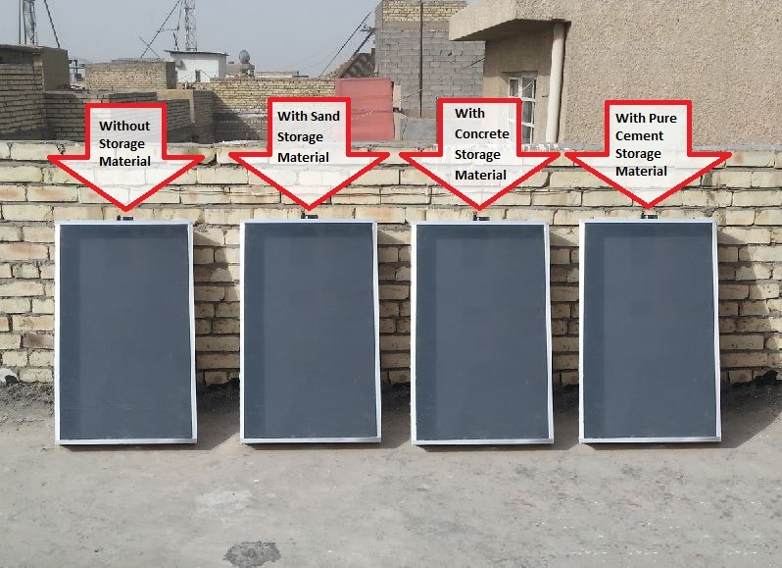

**Fig. (1) Experimental setup**

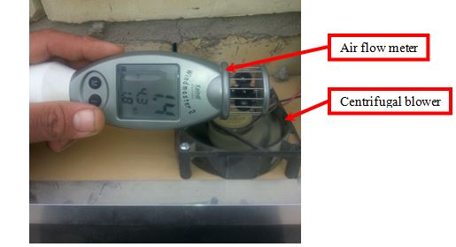

**Fig. (2) Air velocity meter with centrifugal blower**

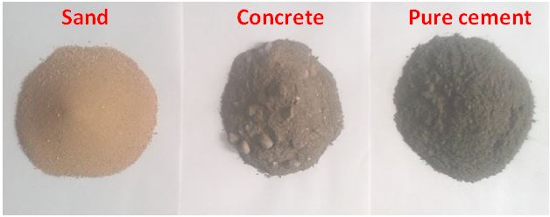

**Fig. (3) Samples of storage heat materials used in this work**

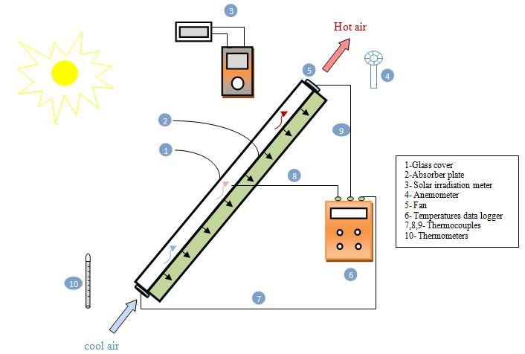

**Fig. (4) Schematic diagram of the SAH principle operation**

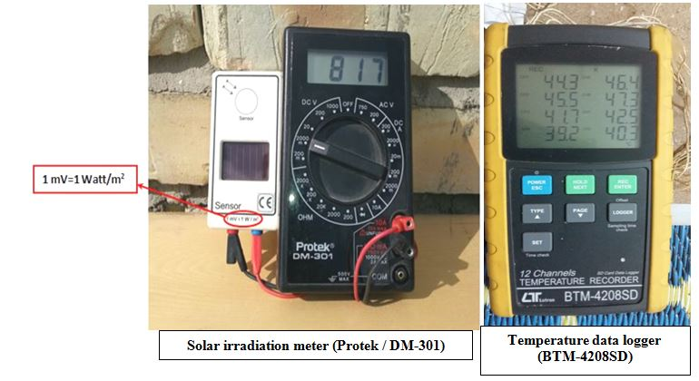

**Fig. (5) Solar irradiation meter with temperature data logger**

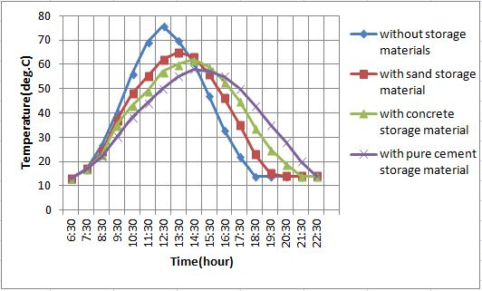

**Fig. (6) Variation of outlet air temperature from SAHs**

**on 8 February 2015 with air velocity 0.8 m/s**

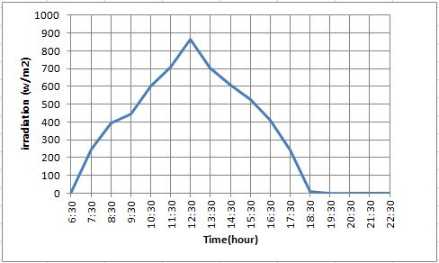

**Fig. (7) Distribution of solar irradiation on 8 February 2015**

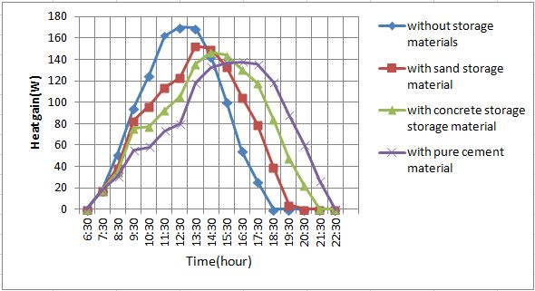

**Fig. (8) Outlet SAHs heat gain on 8 February 2015 air velocity 0.8 m/s**

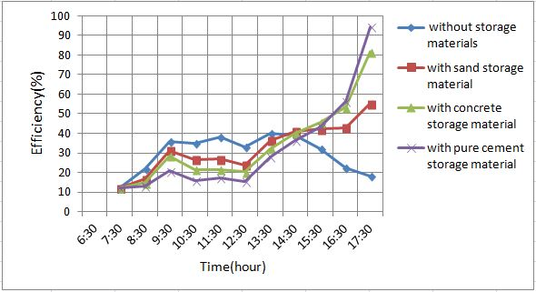

**Fig. (9) SAHs efficiency on 8 February 2015 air velocity 0.8 m/s**

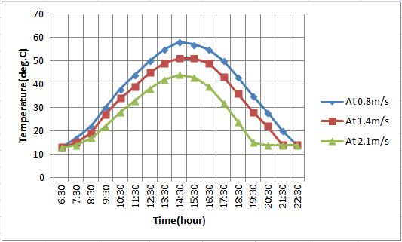

**Fig. (10) Effect of air velocity on outlet air temperature with pure cement storage material on 11 February 2015**

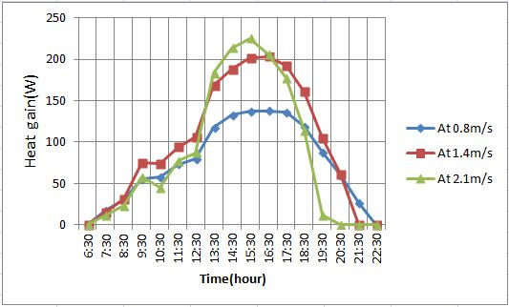

**Fig. (11) Effect of outlet air velocity on heat flux with pure cement storage material on 11 February 2015**

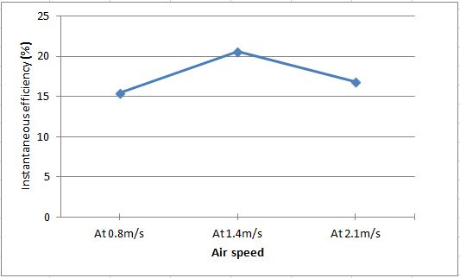

**Fig. (12) Effect of outlet air velocity on instantaneous efficiency on 11 February 2015 (12:30PM) with pure cement storage material**

**6- REFERENCES :**

Abqul-Enein, El-Sebaii A A, Ramadan M R I & El-Gohary H G, Parametric study of a solar air heater with and without thermal storage for solar drying applications, Renewable Energy, 21 (2000) 505-522.

Hassan E S Fath, Thermal performance of a simple design solar air heater with built in thermal energy storage system, Renewable Energy, 6 (1995)1033-1039.

Hawlader M N A, Uddin M S & Khin M M, Microencapsulated PCM thermal energy storage system, Appl Energy, 74 (2003)195-202.

Jain D & Tiwari G N, Thermal aspects of open sun drying of various crops, Energy, 28 (2003) 37-54.

Midilli A, Determination of pistachio drying behavior and conditions in a solar drying system, Int J Energy Res, 25 (2001)715-725.

Mohanraj M & Chandrasekar P, Performance of a solar drier with and without heat storage material for copra drying, in Special issue on Recent Trends in Solar Energy Technology”, Int J Global Energy Issues, 32 (2009) 112-121.

Pangavhane D R & Sawhney R L, Review of research and development work on solar driers for grape drying, Energy Convs Manage, 43 (2002) 45-61.

Sanda Budea, Solar Air Collectors for Space Heating and Ventilation Applications – Performance and Case Studies in Romania Climatic Conditions,1st international e-conference on energies,14-31 march 2014.

Sarsavadia P N, Development of a solar-assisted dryer and evaluation of energy requirement for the drying of onion, Renewable Energy, 32 (2007) 2529-2547.

Sodha M S, Dang A, Bansal P K & Sharma S B, An analytical and experimental study of open sun drying and a cabinet type dryer, Energy Convs Manage, 25 (1985) 263-271.