b=width and h=thickness) ,شكل الصفائحوالزمن.بينما الطبقة المخفية تكونت ثمانية عشر عقدة وعقدة واحدة للخرج (الناتج)يمثلالإجهاد. أبعادالصفائح كانت كالتالي ( a(0.125-0.25)m, b(0.125-0.25)m, h(0.0125-0.025)m)، وحالة الحملثابت(10) qo(kN/m2),وحالة الحملالديناميكية(10-100) qo(kN/m2), to(0.05-0.0005sec.)، إلى (0.05-0.0005sec.).وأظهرت مقارنة النتائج توافق ممتاز بين الدراسات التحليلية وأداءالشبكة العصبيةلحلول مستقلةوإيجاد البيانات.وكذلك تم إجراءالتحققلكلامن نتائج العناصر محددةوالنتائجباستخدام بنى الشبكات العصبيةبشكل عام.

1. **INTRODUCTION :**

Nowadays, the design of structures and components using newly developed composite materials usually requires extensive and expensive testing programs. The analysis of the multi-layered structures has several models take into account the transverse shear effect. Therefore, models based on piecewise approximations in the thickness direction are representing the laminated plate as a multilayered plate. Also there are models which represent the laminated plate by an equivalent single-layer anisotropic plate. Thick hybrid composite plates tend to suffer from local damage, or have local stress concentration regions [Ishai and Hiel,1992]. Optimization methods are focused on the analysis and modeling of composite plates such in [Chakraborty, 2005] proposed an artificial neural network (ANN) delimitation model in order to predict the shape, size, and location of delimitations in laminated specimens with an elliptical embedded delimitation. Rao[Rao and Singh, 1979] give a non-linear mathematical program for the optimum design of laminates for natural frequency. [Kam and Synman, 1991] have proposed a method of inscribed hyperspheres for the optimum design of a laminated plate for strength and stiffness. [Kilic, etal, R 2003] describes an optimal design for a thin plate consisting of multiple layers of equi-thickness composite material for frequency. However, heuristic methods proposed by Morton and Webber [Morton and Webber, 1991] are found to be effective in the optimum design of laminated plates albeit with some difficulty in formulating the rules. The above mentioned analytical methods generally permit optimizations for a small number of constraints. [Issac and Rao, 1992] propose a method for the optimum design of composite laminates against delimitation by ranking the sub laminates. In [Zhang, etal, 2002] investigated the correlation between temperature and dynamic mechanical properties for short carbon fiber composites with two polymeric matrices, and they have used ANN to generate those relations and showed good approximation when compared with experimental results. In [Ghaboussi, etal, 1998], suggested an effective ANN training method, which is termed Auto progressive training in order to effectively train ANNs when a small number of training data (e.g. experimental responses measured from structural tests) are available.This paper introduces a new ANN model, which can generate nonlinear multi-layer stress behaviors of thick composite laminated plates for the entire plane-stress constitutive domain. Both experimental results and Finite element simulation were to generate the ANN training data with different dimensions (a, b, h /m) and static and dynamic loads condition. The neural network model has 6 input nodes representing the load (L) and thick composite size (a=length, b=width and h=thickness), type of lamination, and time. Eighteen nodes at hidden layer and one output node representing the stress. The trained ANN model was able to predict finite element (FE) results for delimitation cases that were not used in the training process and verify the trained ANN model by comparing to other experimental results. Finally, this ANN mode can be used for full and complete nonlinear ANN material model that can cover the entire nonlinear stress–strain spectrum, including the tensile-compression-shear stress paths.

**2. THEORETICAL BACKGROUND :**

An anisotropic composite laminated plate consisting of N-layers of orthotropic lamina has been considered for FE analysis as shown in **Fig. 1(a)** and **(b)**. The plate has been discretized in to a number of three-dimensional elements. Each element lies completely within a lamina and no element crosses the interface between any two successive laminate.[ Sidda Reddya, etal ,2013 ]

ANN synthesized with a number of training data can effectively predict the nonlinear multi-axial stress–strain relations by capturing and generalizing complex behaviors in their connection weights among artificial neurons, even though they are not easily approximated by conventional methods.[ Pannirselvam, etal, 2010 ]

An 18-node three-dimensional mixed FE model shown in **Fig. 1(c)** has been developed by considering the displacement fields *u(x,y,z,t)* , *v(x,y,z,t)*, *w(x,y,z,t)* having quadratic variation along the plane of the plate and cubic variation in transverse direction. The displacement fields are expressed as, .[ Ali, Kim, 2007 ]

$${u_{k}\left(x,y,z,t\right)=\sum_{i-1}^{3}{}\sum_{j-1}^{3}{g_{i }h_{j }a_{o ijk}}+z\sum_{i-1}^{3}{}\sum_{j-1}^{3}{g_{i }h_{j }a_{1 ijk}+}z^{2}\sum_{i-1}^{3}{}\sum_{j-1}^{3}{g_{i }h_{j }a_{2 ijk}+z^{3}\sum_{i-1}^{3}{}\sum_{j-1}^{3}{g_{i }h_{j }a_{\begin{aligned}3 ijk \\ \\ \end{aligned}}k=1,2,3}}………….…….(1)}^{}$$

Where :

$g_{1}-\frac{ζ}{2}$ ( $ζ-1), g_{2}-1-ζ^{2}$, $g_{3}$- $\frac{ζ}{2}$ ( 1 + $ζ)$, $ζ + \frac{x}{L_{x}}$…… ……(2)

$h_{1 -}\frac{δ}{2}\left(δ- 1 \right), h_{2 }-1-δ^{2}$, $h_{3}$- $δ/2$ ( 1 + , …… ……(3)

And

u1 –u ; u2 –v , u3 – w ……………………………………………………………… … …….(4)

Further, the generalized co-ordinates amijk (m=0,1,2,3;I,j,k-1,2,3) are functions of z and the elements’ coordinate axes x, y, z are parallel to the laminate coordinate X, Y, Z. It may be noted that the variation of displacement fields has been assumed to be cubic along the thickness of element although there are only two nodes along z-axis of an element (**Fig. 1(c)**). Such a variation is required for invoking transverse stress components rz, sxzand syzas the nodal degrees-of-freedom in the present formulation. [Sergio, 2011 ]

**3. PROPOSED RBFNN MODEL :**

From the examples ANN captures the domain knowledge. ANN can handle continuous as well as discrete data and have good generalization capability as with fuzzy expert systems. An ANN is a computational model of the brain. They assume that computation is distributed over several simple units called neurons, which are interconnected and operate in parallel thus known as parallel distributed processing systems or connectionist systems. Implicit knowledge is built into a neural network by training it. Several types of ANN structures and training algorithms have been proposed. The proposed ANN material models are illustrated in Fig. 1. It describes a state of plane–stress for a layer or effective state in multiple orthotropic layers. The objective of the trained ANN is to generate multi-axial stress–strain relations. This can be achieved in several ways by using different ANN structures, e.g. type of input and outputs, incremental, or total variables. In this study, a general four layer feed-forward ANN structure is used. The four layers consist of one input, two feed-forward hidden layers, and one output layer. The transfer function for a radial basis neuron is:

radbas (n) = e-n2…………………………………………………………….(5)

This function calculates a layer's output from its net input. For effective predicting of paddle cantilever, the selection of proper inputs and outputs of ANN, structure of the network and training of it using appropriate data should be done with utmost care. In the present paper, **Fig. 2**. Shows the neural network model has 6 input nodes representing the load (L) and thick composite size (a=length, b=width and h=thickness), type of lamination, and time; eighteen nodes at hidden layer and one output node representing the Stress.

**4. RESULTS AND ANALYSIS :**

The developed analytical results, the finite element solution formulation and experimental work, for thick laminated plates, are cover the static and dynamic analysis (for different types of loading) of thick laminated plates, with any type of lamination (symmetric, anti-symmetric, cross-ply, angle-ply, and other lamination) and with different parameters and boundary conditions. Dimensions of Plates ( a(0.125-0.25)m, b(0.125-0.25)m, h(0.0125-0.025)m), and Static load condition (10) qo(kN/m2), the dynamic load condition (10-100) qo(kN/m2), to(0.05-0.0005sec.). To train RBFNN model with the results of the finite element analyses and experimental work, network architecture was required; first the entire training data file was randomly divided into training and testing data sets. About 90% of the data 84 patterns, were used to train the different network architectures where remaining 8 patterns were used for testing to verify the prediction ability of each trained NN model. Since RBFNNs Learn relations and approximate function mapping limited by the extent of the training data, the best use of the trained RBFNN models can be achieved in interpolation as shown in **Table 1**. This neural network was simulated using the scientific and engineering package MATALB® 7.2.

From the analysis of the results in **Table 1** and **Fig. (4,5)**, it is observed that the accuracy of the RBFNN method was slightly superior when compared to the experimental on account of mean average error (MAE). **Fig. 7** shows a plot of experimental against corresponding RBFNN prediction. A linear behavior of stresses can be observed in **Table 2** and **Fig. (6)** ,between two different load and four layers lamination.

**5. CONCLUSIONS:**

Laminated composites are widely used in the engineering field due to their excellent mechanical properties. The development of mathematical models for prediction of the dynamic behavior of the physical models with sufficient accuracy is great interested. Present paper is an attempt to develop laminated composite structures, design variables related to optimum configurations may be the number of laminates, fiber orientation angles and thickness of each layer. Various experimental and analytical or numerical methods using FEA have been developed to determine the residual stresses in polymer–matrix composites. The ANN model is ANN is expected to be very helpful to predict the material properties before manufacturing or testing the real composites .Beside , it will be an additional help in the design of new composite materials, through the analysis of relationships between some simple properties and other complex properties .Therefore, it is required for an accurate analysis of multi-layered composite structures under general condition of loading and supports in order to incorporate most of the behavioral requirements. Results comparisons performed to verify the stiffness design of structures of laminated composite materials and the computational processing time using FEA or ANN are also verified.

**Table 1 Sample of experimental data**

|  |  |  |  |  |  |  |
| --- | --- | --- | --- | --- | --- | --- |
| lamination | | Dimension (a,b,h)m | | | Static Load qo(kN/m2) | Stress |
| A | b | H |
| 4-layers | | .1 | .1 | .01 | 10 | 1.17E+06 |
| .125 | .125 | 0.125 | 10 | 1.84E+06 |
| .15 | .15 | .015 | 10 | 1.52E+06 |
| 4- layers | | Dimension (a,b,h)m | | | t  sec. | Stress |
| A | b | H |
| .125 | .125 | 0.125 | 0.005 | -0.2e+07 |
| .125 | .125 | 0.125 | 0.010 | -0.43e+07 |
| .125 | .125 | 0.125 | 0.015 | -0.97e+07 |
| .125 | .125 | 0.125 | 0.025 | -1.0e+07 |
| .125 | .125 | 0.125 | 0.030 | -1.46e+07 |
| .125 | .125 | 0.125 | 0.050 | -2.47e+07 |
| .125 | .125 | 0.125 | 0.055 | +2.23e+07 |
| .125 | .125 | 0.125 | 0.060 | -0.11e+07 |
| .125 | .125 | 0.125 | 0.065 | -2.22e+07 |
| .125 | .125 | 0.125 | 0.070 | -0.2e+07 |
| 8- layers | Dimension (a,b,h)m | | | t  sec. | Stress |
| A | b | H |
| .125 | .125 | 0.125 | 0.005 | -0.17e+07 |
| .125 | .125 | 0.125 | 0.010 | -0.38e+07 |
| .125 | .125 | 0.125 | 0.015 | -0.82e+07 |
| .125 | .125 | 0.125 | 0.025 | -0.89e+07 |
| .125 | .125 | 0.125 | 0.030 | -1.37e+07 |
| .125 | .125 | 0.125 | 0.050 | -2.25e+07 |
| .125 | .125 | 0.125 | 0.055 | +2.19e+07 |
| .125 | .125 | 0.125 | 0.060 | -0.08e+07 |
| .125 | .125 | 0.125 | 0.065 | -2.16e+07 |
| .125 | .125 | 0.125 | 0.070 | -0.17e+07 |

**Table 2 Comparison between two different loads**

|  |  |  |  |  |  |
| --- | --- | --- | --- | --- | --- |
| lamination | Dimension (a,b,h)m | | | Load  qo(kN/m2) | Stress |
| A | b | H |
| 4-layers | .1 | .1 | .01 | 10 | -0.08e+07 |
| .1 | .1 | .01 | 100 | 1.55e+07 |
| .125 | .125 | 0.125 | 10 | -0.20e+07 |
| .125 | .125 | 0.125 | 100 | 2.22e+07 |
| .15 | .15 | .015 | 10 | -0.12e+07 |
| .15 | .15 | .015 | 100 | 1.85e+07 |

**Table 3 Comparison between Experimental and RBFNN**

|  |  |  |  |  |  |  |  |
| --- | --- | --- | --- | --- | --- | --- | --- |
| lamination | Dimension (a,b,h)m | | | | Load  qo(kN/m2) | Experimental Stress | RBFNN Model Stress |
|  | a | b | | h |  |
| 4-layers | .1 | | .1 | .01 | 10 | -0.11e+07 | -0.08e+07 |
| .1 | | .1 | .01 | 100 | 1.46e+07 | 1.35e+07 |
| .125 | | .125 | 0.125 | 10 | -0.27e+07 | -0.20e+07 |
| .125 | | .125 | 0.125 | 100 | 2.43e+07 | 2.27e+07 |
| .15 | | .15 | .015 | 10 | -0.16e+07 | -0.12e+07 |
| .15 | | .15 | .015 | 100 | 2.15e+07 | 1.85e+07 |

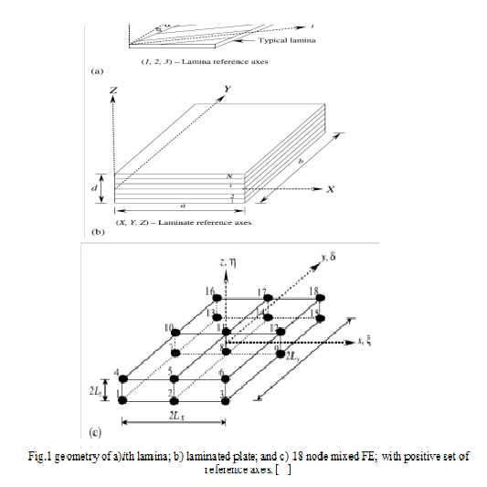

**Fig.1 geometry of a)*i*th lamina; b) laminated plate; and c) 18 node mixed FE; with positive set of reference axes. [Zhang, Friedrich, 2003 ]**



**Fig. 2 ANN structure for plane–stress nonlinear material models.[** Zhang, Friedrich, 2003**]**

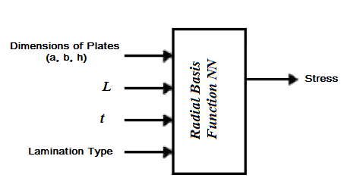

**Fig. 3 Schematic drawing of RBFNN model [**Zhang, Friedrich, 2003**]**

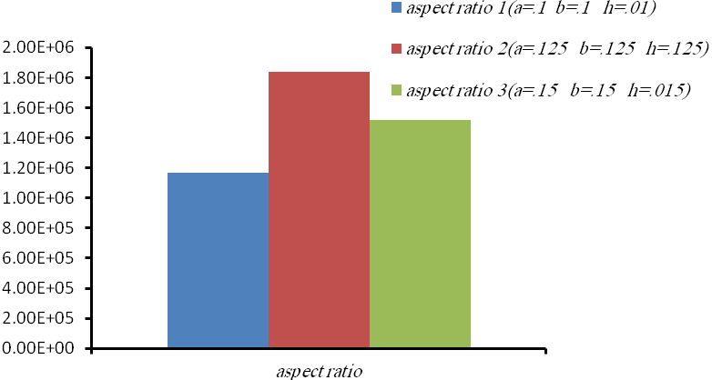

***Stress N/m2***

**Fig.4 Sample of experimental stress for Static Load qo(kN/m2 ) &4-layer**

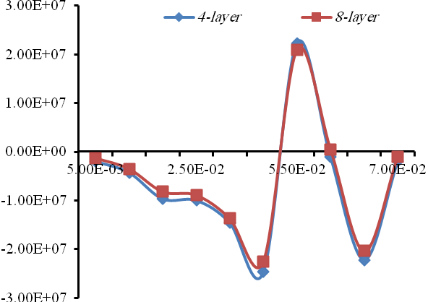

***Time sec.***

***Stress N/m2***

**Fig.5 Sample of experimental stress for dynamic Load qo(kN/m2 )**

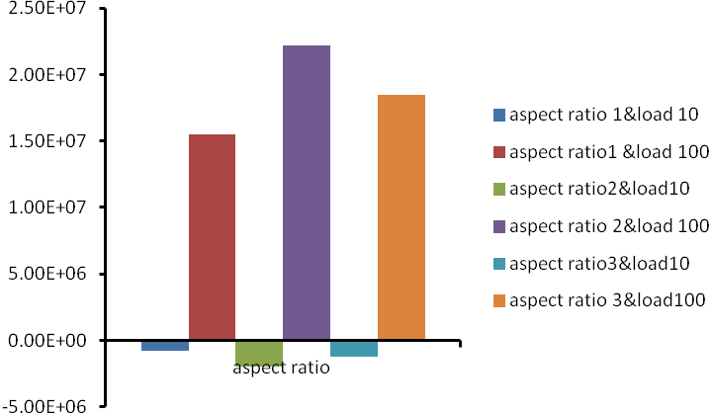

***Stress N/m2***

**Fig. 6 Comparison between two different loads qo(kN/m2 ) &4-layer**

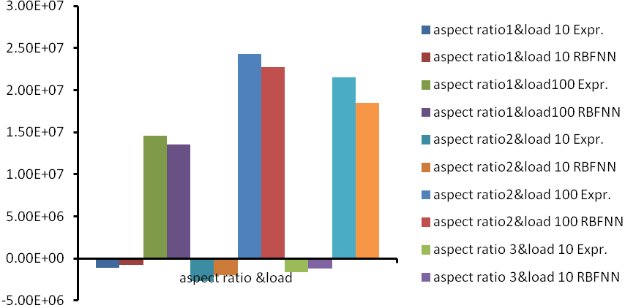

***Stress N/m2***

**Fig. 7 Comparison between Experimental and RBFNN for loads qo(kN/m2 ) &4-layer**

**6. REFERENCES :**

Ishai and C. Hiel, "Damage tolerance of a composite sandwich with interleaved foam core", J. compos. Tech&. Res. 14(3), pp.155-168, 1992.

Chakraborty, "Artificial neural network based delimitation prediction in laminated composites", Mater. Des. 26 (1), pp.1–7, 2005.

S. S. Rao and K. Singh, "Optimum design of laminates with natural frequency constraints",I. Sound. Vibr. 67, pp.101-112,1979.

T. Y. Kam and J. A. Synman," Optimum design of laminated composite plates using a global optimization technique",Compos. Struct. 19, pp.351-370,1991.

Kilic, H., Haj-Ali, R.," Progressive damage and nonlinear analysis of pultruded composite structures", Compos. Part B: Eng. 34 (3), pp.235–250, 2003.

S. K. Morton and J. P. H. Webber., "Heuristic methods in the design of composite laminated plates", Compos. Stra. 19, pp.207-265, 1991.

J. C. Issac and K. P. Rao, "Optimum design of composite laminates against delamination by ranking", J. Reinforced Plastics Compos. 11, pp.684-706,1992.

Zhang, Z., Klein, P., Friedrich, K., 2002.," Dynamic mechanical properties of PTFE based short carbon fibre reinforced composites: Experiment and artificial neural network prediction", Compos. Sci. Technol. 62 (7–8), pp.1001–1009, 2002.

Ghaboussi, J., Pecknold, D.A., Zhang, M., Haj-Ali, R.M," Auto progressive training of neural network constitutive models", Int. J. Num. Meth. Eng. 42 (1), pp.105–126, 1998.

B. Sidda Reddya, J. Suresh Kumarb, and K. Vijaya Kumar Reddyb "Prediction of Deflection and Stresses of Laminated Composite Plate with an Artificial Neural Network Aid" ,International Journal of Applied Science and Engineering 2013. 11, 4: 393-413 *Int. J. Appl. Sci. Eng., 2013. 11, 4* 393.

N. Pannirselvam, V. Nagaradjane, K. Chandramouli,and M. Ravindrakrishna," Artificial neural network model for performance evaluation of RC rectangular beams with externally bonded glass fiber reinforced polymer reinforcement ", vol. 5, no. 3, March 2010 ISSN 1819-6608 ARPN Journal of Engineering and Applied Sciences ©2006-2010 Asian Research Publishing Network (ARPN). All rights reserved. www.arpnjournals.com.

Rami Haj-Ali, Hoan-Kee Kim , " Nonlinear constitutive models for FRP composites using artificial neural networks", Mechanics of Materials 39 (2007) 1035–1042.

Sergio D. Cardozo., Herbert. M. Gomes and, and Armando. M. Awruch, " Optimization of laminated composite plates and shells using genetic algorithms, neural networks and finite elements" , Latin American Journal of Solids and Structures 8(2011) 413 – 427.

Z. Zhang, K. Friedrich, " Artificial neural networks applied to polymer composites: a review ", Composites Science and Technology 63 (2003) 2029–2044