**INTRODUCTION :**

The main problems in design criteria for aerospace composites are the establishment of meaningful failure criteria for fatigue of fiber reinforced materials. There exists a huge are on the fatigue failure of metals which are homogeneous and isotropic materials, yet the problem of metal fatigue failure criteria is far from resolved. In contrast to metals, fiber reinforced materials are heterogeneous and anisotropic. It is therefore unfortunately to be expected that the problem of fatigue failure in these materials is even more difficult than for metals[Van Paepegem 2001].

Fatigue is the progressive and localized structural damage that occurs when a material is subjected to cyclic loading. The maximum stress values are less than the ultimate tensile stress limit, and may be below the yield stress limit of the material. Failure of a material due to fatigue may be viewed on a microscopic level in three steps

***(a) Crack Initiation -*** The initial crack occurs in this stage. The crack may be caused by surface scratches caused by handling, or tooling of the material; threads (as in a screw or bolt); slip bands or dislocations intersecting the surface as a result of previous cyclic loading or work hardening.

***(b) Crack Propagation -*** The crack continues to grow during this stage as a result of continuously applied stresses.

***(c)Failure -*** Failure occurs when the material that has not been affected by the crack cannot withstand the applied stress. This stage happens very quickly[M. M. Alam 2005].

Most of Fiber Composite Structures are made of laminates which consist of uni-axially reinforced lamina. Given the very large variety of laminates, it is an impossible task to determine fatigue failure criteria of any degree of generality by experiments only. Such experiments have been performed and are worthwhile once it has been decided to use a specific laminate and its fatigue characteristics are required. But it cannot be expected that guide lines for choice of laminates on the basis of desirable fatigue properties could be obtained in this manner. A more hopeful avenue of approach is to attempt to establish a fatigue failure theory of laminates on the basis of fatigue failure criteria of the constituting lamina. Thus, it is necessary first to establish fatigue failure criteria for uni-axially reinforced materials. The present work is concerned with this problem fatigue failure criteria basically. In search for guidelines to o reasonable approach to this extremely difficult problem, it is important to examine the best approaches to the much simpler yet formidable problem of static failure criteria of uniaxially reinforced materials. There are basically two kinds of approaches: the Micro-approach and the macro-approach. In the first of these, possible failure modes are examined on the basis of detailed local failure development, such as fiber breakage or buckling, interface de-bonding and matrix cracking or yielding [Wahl,N W. 2003]. Because of the great inherent difficulties, such investigations have been almost exclusively limited to simple applied loads such as simple tension and compression or pure shear.

In the second approach, it is assumed that failure can be described by a macroscopic criterion, mostly in terms of the average stresses to which the composite is subjected. The criterion contains unknown parameters which must be determined in terms of failure stresses in simple and experimentally realizable loadings. For recent discussion [Freiere R. C.,2005 ][P.D.la-Cruz,1998] The approach to be adopted in the present work may be described as a macro-approach which is based on laser treatment guidelines in that the specific form of the criterion is chosen on the basis of observed failure modes in the material.

The use of lasers to modify the surfaces of metals in order to increase the resistance of heat, wear, corrosion, and erosion has significant growth potential for manufacturing industries. In LSH (laser surface hardened) higher heating and cooling rates of 108 to 1010 oC/s are involved to modify the surface and mechanical properties of the metallic components. These higher heating and cooling rates could generate superior microstructures and excellent surface and mechanical properties. Laser surface hardening has demonstrated its capability to tailor properties of a surface locally as well as in bulk [ASM Handbook 2013][J. Jiang,2011].

Laser systems offer actually some of the most advanced today’s technologies from the productivity, precision and flexibility points of view[Alexandru 2012].

The aim of this work is to investigate the fatigue behaviors with laser surface hardened for composite material (fiber glass reinforcement) specimens and to compare the result for laser transformation hardening with those of withot laser treatment. Moreover, the fatigue properties of the composite material under laser treatment test conditions were also studied.

**Theoretical Analysis Volume and Weight Fraction of Aligned Continuous Fiber**

To define the fiber volume fraction *Vf* and the matrix volume fraction *Vm* consider a composite consisting of fiber and matrix, [Hull, D. 1996].

$$V_{m}=\frac{v_{m}}{v_{c}}=\frac{A_{m}}{A_{c}}……………………………………………………..….\left(1\right)$$

$$V_{f}+V_{m }=1……………………………………………….……..……(2)$$

The mass fraction (weight fraction) of the fibers (*M****f***) and the matrix (*M****m***) are defined as:

$M_{f}=\frac{w_{f}}{w_{c}}$

………………….(3)

$$M_{f}=\frac{w_{m}}{w_{cf}}$$

*Mf +Mm =1*

Of a single material in terms of the fiber from the definition of the density and matrix volume fractions:

$M_{m}=\frac{ρ_{m}}{ρ_{c}}V_{m}$

$M_{f}=\frac{ρ_{f}}{ρ_{c}}V_{f}$

…………………….. (4)

In terms of individual constituent properties, the mass fractions and volume fractions are related by:

$M_{f}=\frac{V_{f}}{V_{f }+\left(1+V_{f}\right)\frac{ρ_{m }}{ρ_{f} }}$

…………… . .(5)

$$V_{f}=\frac{M_{f}}{M_{f }+\left(1+M_{f}\right)\frac{ρ_{f }}{ρ_{m} }}$$

The density of the composite *(c)* in terms of the constituents’ weight fractions and densities can be defined as:

$$ρ_{c}=\frac{1}{\frac{M_{m}}{ρ_{m}}+\frac{M_{f}}{ρ_{f}}}……………………………………… …(6)$$

It is evident that volume and mass fractions are not equal and that the mismatch between the mass and volume fractions increases as the ratio between the density of fiber and matrix differs from one.

**Experimental Procedure**

E-glass fibers having density of 2.5 g/cm3 and modulus of 7.2 GPa were used as a reinforcing material in polyester matrix with steel layer was added in canter of some spasment . The polyester, Syropole 8340 is an unsaturated resin with catalyst addition; having a density of 1.22 g /cm3 and elasticity modulus 2.82 GPa was used as the matrix material, [Hayder 2007].

**Specimen Preparation**

Composite panels were prepared according to ASTM standard D5687 [ASTM 2007] and through a hand lay- up process. The panel thickness and lamina orientations were controlled by performing the lay-up process in a specially made mold frame. The frame was manufactured from steel plate in the workshop with two thicknesses *6 mm* for the base and *12 mm* for the heavy weight cover, net molding area was *25*25 cm*2. The layers thickness was controlled to *1 mm* by using a steel ruler fixed to the frame, *12* vertical fastener bolts were welded in the base for tighten in the rulers to keep the fibers strung. The cover was applied to prevent any buckling occurring during the curing process. The curing process was completed in 24 hrs at room temperature, followed by oven cure at 70Co for three hours. The specimens were cut out of the 25x25 cm2 panels according to ASTM D3479-76 standards [AX Short Course 2003]. The specimens were dog bone shaped with the dimensions as shown in figure (1). Four layer composite specimens were prepared at a layer thickness of 1mm. [+45/-45]s and [0/90]s composite laminates were prepared and used in the paper. The difference is the weight fraction *Mf* of the fiber in the composite, However, this facility was not available and an alternative method was used by weighing the fibers before lay-up and then weighting the composite panel after curing and calculation using strength ratio mechanics (SRM) formula given in equation (4).

a-Fiber weight before lay-up was (*110.76*) *gm*

b-Composite panel weight after curing was (*318.5*) *gm*

c-Then *Wf*=*0.3478*, which gives a volume fraction value of about (*0.202*).

The volume fraction of the fiber in the composite was 0.22. The engineering constants of the laminates were extracted from tensile measurements, [Hayder 2007].

and are given in Table (1).

Nd:YAG laser wavelength 1064 nm ,card 1000 mJ , and 6 Hz frequency was used with other device ( continuous laser diode at a wavelength of 532 nm and card 1 watt). The specimens were firstly treatedby conventional heat treatment and then with laser respectively. Conventional heat treatment forthe specimens was carried out as follows:Heating at 70Co for 7hr frequency of laser system is 1-6HZ with wave length 1064 nm and pulse duration 100ns.The laser treatment was performed a 1 (J) .The hardness profile along thedepth of the cross section in the hardened surface layer was measured byusingof 250gm and a holding time of 15seconds. The specimens were characterized byOptical Microscopy (OM).Figure (3) shows the laser apparatus

**Fatigue test**

The Fatigue test of composite material was carried out by using Fatigue Testing Machine Type *7305* to compute the fatigue life of the specimens before and after treatments proposed in this work**.** The test samples as shown in Fig.(1 ) were stressed cyclically with presence a fully reversed (R=-1)sinusoidal load 1 N.m for all specimens to simulate the fatigue test conditions. Fatigue test was performed by changing of the applied loading in the range of 0.2 to 2.8 N.m. using the Fatigue Testing Machine Type 7305 shown in Fig.(2).When comparing the results of this fatigue model to existing models, we find that it is to some degree acceptable. We assumed that there are no residual stresses in the unglazed rail, which resulted in a longer fatigue life when compared to an existing model and/or to field values[S. Aldajah 2009]. When electromagnetic radiation from laser light interacts with the surface of a conductor, the combination of electric and magnetic field will affect the distribution of alternating current inside a sample. This causes electric currents to flow in the conduction band electrons near the surface of the sample. These conduction band electrons near the surface shield the interior of the sample from the radiation. The shielding is such that most of the absorption and reflection taken place very close to the surface within what is called the “skin depth” and generally denoted by d. The penetration and absorption of an electromagnetic field into a solid is attenuated exponentially[Mohammad 1998].Before the fatigue test, the specimens treated (heated) by laser at different positions using two types of intensity laser (pulse point Nd:YAG ,and continuous ) as shown in fig.(3). The age of the fatigue life of the samples in the material and the reinforced fibers were calculated**.**

**RESULTS AND DISCUSSION :**

The tests were executed on samples with the dimensions shown in figure (3-c) in order to determine the S-N curves (fatigue life). The samples were treated with laser pulse and band by two devices as shown in figure (3a and b) at different locations of the sample , as shown in figure (4 ). The first was at the specimen center, the second between the center and the edge and the third on the edge of the specimen. The band laser was applied at two locations, the first at the center of the sample and the second on either sides of the center. Fig (5) shows that the specimen with fiber unidirectional without reinforced vulnerable to pulse laser in the center shows longer fatigue life than other sites to applied pulse laser and followed the specimen exposed to pulse laser in the region between the center and edge .The specimen exposed to laser at age shows less fatigue life than the rest . Figs (6) and (7) show S-N curves for samples of fiber composites (0/ 90),(- 45/45 ) laser treated at the same previous positions. It also give the center area of the longest fatigue life, while the rest were less. The rates of this behavior for a property that resulted from the laser treatment hardening, which in turn gives the longest fatigue life Penchant certain because of the different sites affected by laser treatment was different solidification of the sample had the least impact on the age of the sample is hardening the surface ( edge site).Fig( 8) present was extracted S-N curve once without any treatment , second and a third was the presence of treatment band laser at sites the center and on both sides of the center (as shown figure 3) The age of samples longer than in the case of treatment pulse laser , and the center position laser treatment was best than on either side of the center. Approximately same thing about the figs (9) and (10) when the for the samples (90/0), (-45/45) . It should be noted here that there are some few samples gave results nature are not taken into consideration because of manufacturing defects sample.   
Fig. (11) shows the extracted S-N Curve samples of unidirectional fiber composite in the absence of layer relay marginal and laser band treatment. In the case of a reinforcement layer marginal and the absence of the both, the first case less fatigue life than other, while it was the latter case which has the longest fatigue life, especially in the few stresses case. The same thing almost observed in the Figs (12) and (13). They are related to the fiber composite samples (0/90), (-45/45), except for the clarity of the effect of laser treatment and reinforcement the longevity of the samples better

**CONCLUSIONS**

1-Laser surface treatments lead to improve fatigue life rate more than conventionally heat treatment.

2-Increasing load and time lead to increase fatigue life rate for all the specimens.

3-Laser surface treatments lead to increase the fatigue life rate in the surface of the specimens.

4-position and type (pulse and band) of hardening by laser decreasing far from the center of specimen.

Table**le (1)Mechanical properties of composite laminates** **[Hayder 2007].**

|  |  |  |  |  |  |  |  |  |  |
| --- | --- | --- | --- | --- | --- | --- | --- | --- | --- |
| *laminates* | *E1*  *(GPa)* | *E2*  *(GPa)* | *E3*  *(GPa)* | *G1*  *(GPa)* | *G2*  *(GPa)* | *G3*  *(GPa)* | *V­­­12* | *V­­­13* | *V­­­23* |
| [0]s | 18.04 | 3.74 | 3.74 | 1.57 | 1.57 | 1.49 | 0.34 | 0.34 | 0.25 |
| [-45/45]s | 5.03 | 5.03 | 6.75 | 4.93 | 1.53 | 1.53 | 0.21 | 0.15 | 10.15 |
| [0/90]s | 11.04 | 11.04 | 6.75 | 1.57 | 1.53 | 1.53 | 0.12 | 0.32 | 0.32 |

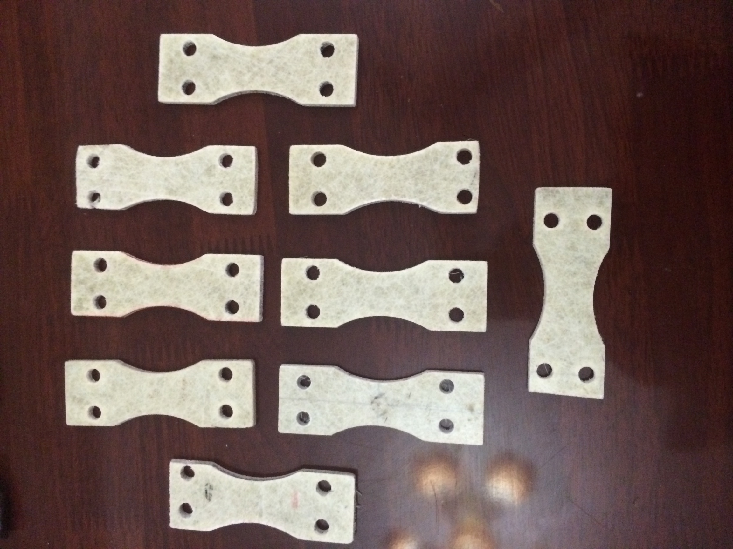

**Fig. (1) Fatigue specimens**

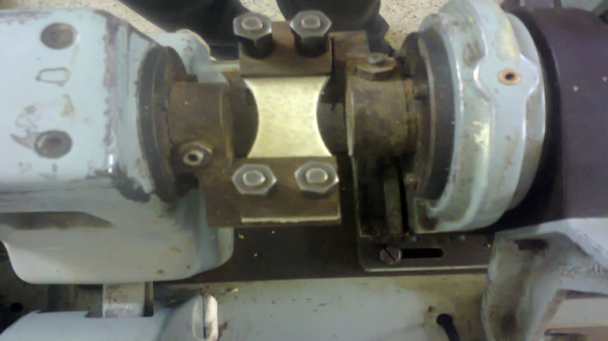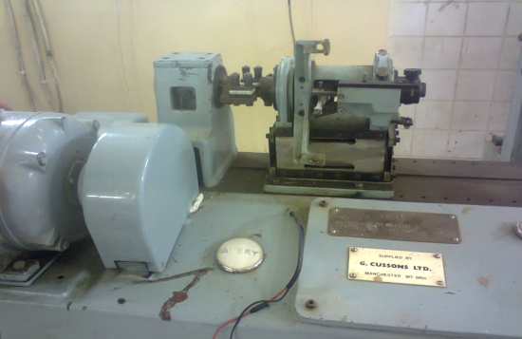

(a)Fatigue device (b)Fatigue device



**(c) specimen dimensions**

**Figure (2) Fatigue device and specimen dimensions**

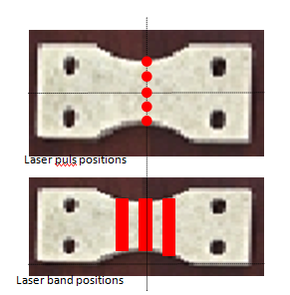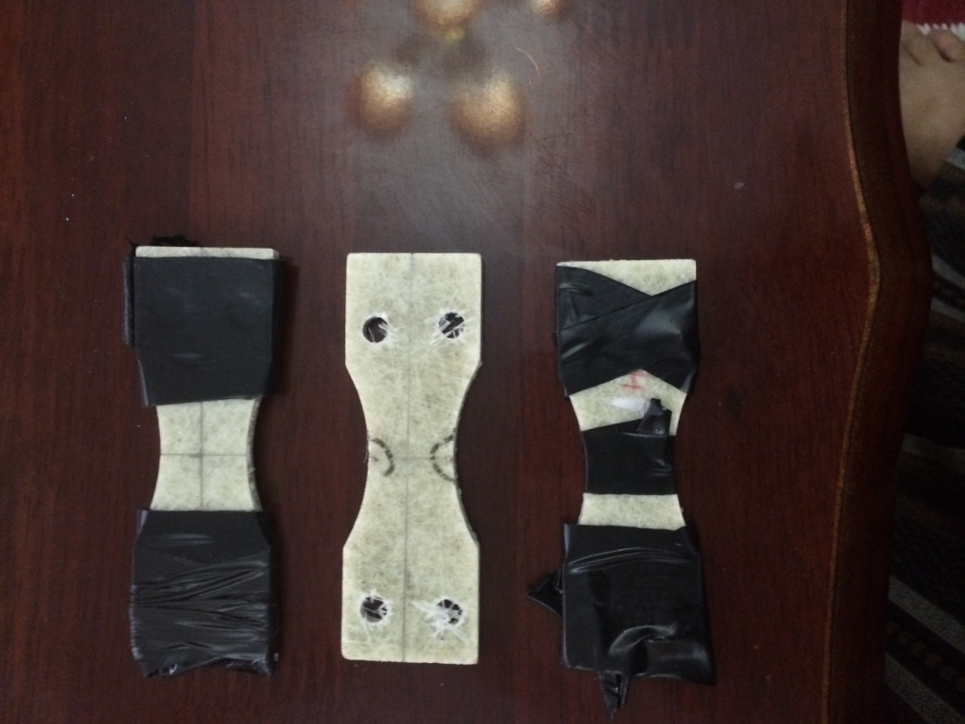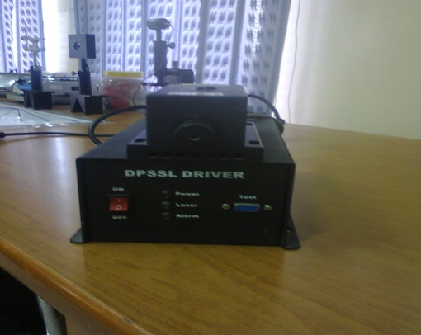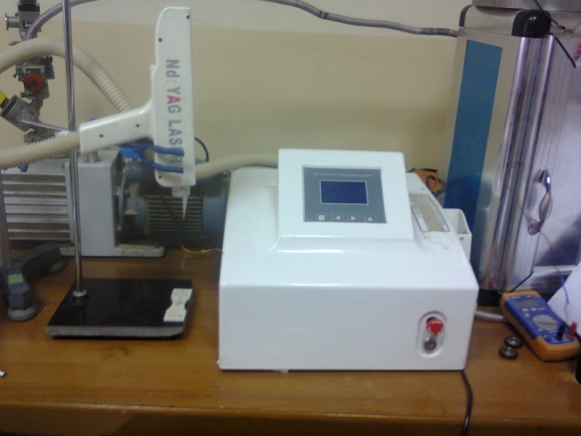

**Figure (4) : laser treatment positions**

1. **pulse**
2. **band**

**Figure(3) laser devices: a)pulse (Nd : YAG )**

**Figure ( 5) S-N curve for Uni-direction, with and without center and edge and between them *puls* laser treatment**

**Figure ( 6) S-N curve for 0/90, with and without center and edge and between them *puls* laser treatment**

**Figure (7) S-N curve for 45/-45, with and without center and edge and between them *puls* laser treatment**

**Figure (8): S-N curve for Uni-direction, with and without center and near band laser treatment**

**Figure( 9) S-N curve for 0/90, with and without center and near *band* laser treatment**

**Figure( 10) S-N curve for 45/-45, with and without center and near *band* laser treatment**

**Figure (11) S-N curve for uni- direction, with and without laser treatment and steel reinforcement**

**Figure( 12) S-N curve for 0/90, with and without laser treatment and steel reinforcement**

**Figure ( 13) S-N curve for uni-direction , with and without laser treatment and steel reinforcement**

**REFERENCE :-**

**Alexandru Nichici and Ramona Cristina Laslau," Factors Affecting the Energy Consumption in Pulsed Nd: YAG Laser Cutting of Glass Fiber/epoxy Composite" Material Plastic , 49, No.4 , 2012.**

**ASM Handbook, Volume 4A, Steel Heat Treating Fundamentals and Processes Jon Dossett and George E. Totten, editors Copyright @ 2013 ASM InternationalW All rights reserved** [**www.asminternational.org**](http://www.asminternational.org) **.**

**Freire, R. C., and Aquino E. F. “Fatigue Damage Mechanism and Failure Prevention in Fiberglass Reinforced Plastic”,Materials Research, Vol. 8, No. 1, 45-49, 2005.**

**Hayder Al-Shukri," Experimental and Theoretical Investigation into Some Mechanical Properties of E-glass Polyester Composite under Static and Dynamic Loads", M.Sc. Thesis, Engineering Electromechanics Department, University of Technology ,2007.**

**http://mihd.net/yn9up8, ASTM D5687/D5687M-95, "Standard Guide for Preparation of Flat Composite Panels with Processing Guidelines for Specimen Preparation",. Book of Standards Volume: 15.03.. 2007.**

[**http://www.usna.edu/Users/mecheng/pjoyce/composites/Short_Course_2003/12_P AX_Short_Course_Mechanical-Testing.pdf**](http://www.usna.edu/Users/mecheng/pjoyce/composites/Short_Course_2003/12_P%20AX_Short_Course_Mechanical-Testing.pdf)

**Hull, D. and Clyue, T.W. “An Introduction to Composite Materials” 2nd edition Cambridge solid-state science, series, 1996.**

**J. Jiang, L. Xue, and S. Wang, Discrete Laser Spot Transformation Hardening of AISI O1 Tool Steel Using Pulsed Nd: YAG Laser, Surf. Coat. Technol., Vol 205, 2011, p 5156–5164.**

**M. M. Alam, Z. Barsoum, P. Jonsén, H. A. Häggblad, and A. F. H. Kaplan," Fatgue Behavior Study of Laser Hybrid Welded Eccentric Fillet Joints– Part I " www.ltu.se/tfm/produktion, 2005.**

**Mohammad Ali Rezaizadeh "Pulsed-Laser Ultrasound Generation in Fiber-Reinforced Composite Material" thesis November 3, 1998 Blacksburg, Virginia .**

**P.D. la-Cruz, M. Oden, and T. Ericsson, Effect of Laser Hardening on the Fatigue Strength and Fracture of a B-Mn Steel, Int. J. Fatigue, Vol 20 (No. 5), 1998, p 389–398.**

**S. Aldajah "Effect of Laser Glazing Process on Rail contact Fatigue Life Emirates" Journal for Engineering Research, 14 (1), 39-46 (2009)(Regular Paper).**

**Van Paepegem, W., and Degrieck, J. “Experimental setup for and numerical modelling of bending fatigue experiment on Woven Glass/Epoxy Composites”, Composite Structure, Vol.51 (1), pp.1-8, 2001.**

**Wahl, N. W. and Samborsky, D. D. “Effect of Modeling Assumptions on the Accuracy of Spectrum Fatigue Lifetime Predictions for a Fiberglass Laminate”, AIAA,Vol.0023, 2003**